Chichester City Building Stones Walk – Sunday July 26th

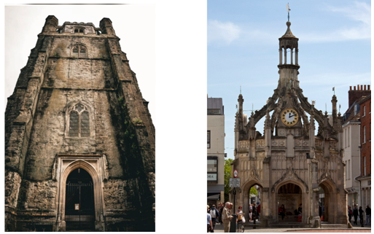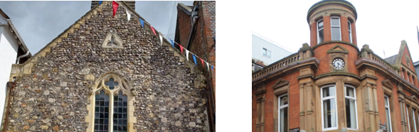

The trip will be led by David Bone who has led many trips for the Open University Geological Society and they are always highly informative and interesting.

In this trip, we will explore the city to discover the many historic building stones, many of local origin, that have been used from Roman through to Victorian times and the stories behind them. We will examine the use of local rocks used in the city's architecture. A handout will be provided.

The walk will be about 2.5 km to 3km long, on the flat at an easy casual pace. We will break for lunch, either bring your own (preferred) or use one of the many cafes in the city centre.
We will finish around 4.30 pm but I would advise organising parking until 5pm to be safe rather than underestimating the time needed.

