20th – 24th October. Gloucester Field Trip (Forest of Dean, Wye Valley, Severn Vale) (Leader: Dave Green)

This trip will be led by Dave Green who is putting together a splendid and informative trip for us and we will have 3 full days in the field (21st,22nd and 23rd October). There may be some changes, but below is a provisional itinerary.

Tuesday 20th October:
We will make our own way to the hotel in time for an evening introductory talk and evening meal.
Wednesday 21st October:
In the morning we will examine the Lower and Middle Jurassic sediments (marlstone, sands, carbonates) of the Cotswold Edge escarpment (probably at North Nibley and or Wotton-under-Edge
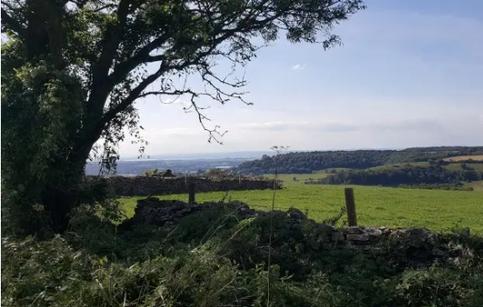
The afternoon will be spent visiting various locations within the Tortworth Palaeozoic inlier (LLandovery volcanics, Wenlock carbonates and mudstones, Carboniferous carbonates and Triassic mudstones with celestine).
Thursday 22nd October:
The morning is likely to consist of a mostly downhill walk traversing the Silurian May Hill inlier (Llandovery (sandstones), carbonates and mudstones, mudstones of the Old Red Sandstones)
The afternoon will be spent at several locations to view the Upper Triassic/Lower Jurassic of the Severn Vale e.g. Garden Cliff, Westbury on Severn.
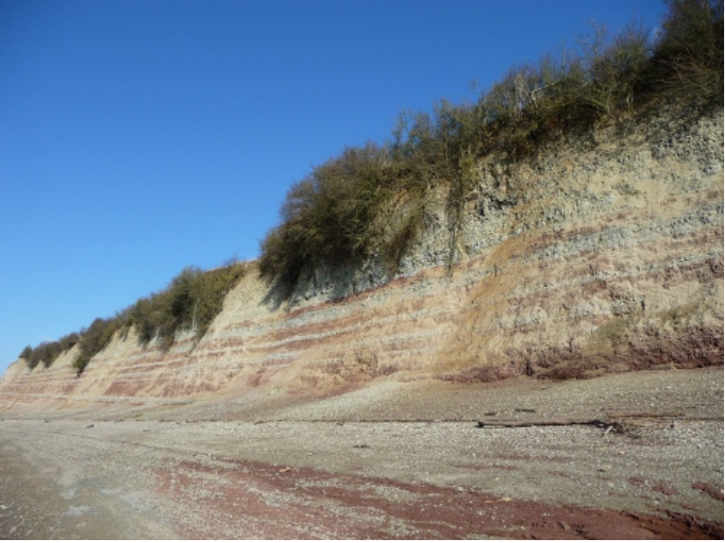

Friday 23rd October:
Friday will focus on the Old Red Sandstone and Carboniferous of the Forest of Dean and Wye Valley.
The morning is likely to consist of a mainly level walk traversing the ORS (sandstones and conglomerates) and Carboniferous (dolomitised limestones, mudstones, sandstones and coal measures) of the eastern limb of the Forest of Dean syncline at Upper Soudley.
In the afternoon we will visit the Wye valley to see upper ORS sandstones and Lower Carboniferous carbonates with some stunning views either at Symonds Yat or St Briavels.
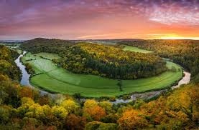
Saturday 24th October:
We will check out and make our separate ways home (some of you may prefer to leave on the evening of the 23rd).
Accommodation
You will need to each book your own accommodation from 20th October either for 3 or 4 nights (depending on whether you wish to leave on Friday night after a full day in the field or after breakfast on the following Saturday morning).
Our base hotel will be The Thatch Inn in Gloucester which is willing to accommodate us all subject to availability. Their details are on the booking form and they offer free cancellation up to the day beforehand. Book as soon as possible if you wish to stay at this hotel. If you wish to stay elsewhere, please ensure that wherever you book has reasonable cancellation provisions should you need to pull out or in the unlikely event that the trip has to be cancelled for any reason. Please do not book your accommodation until you have not only completed the field trip booking form and sent the deposit but also received confirmation that you have a place.
Deposit
The deposit required to secure your place on this trip is £45. Deposits will be refunded if the trip is cancelled for any reason. At the beginning of October, we will calculate the actual price per attendee based on the numbers signed up and ask for a second payment being the balance. Please see the booking form for further details

